Dataset Description
The dataset used in this study contains air pollution measurements collected from multiple air quality monitoring stations across various cities in India. The data includes information about different atmospheric pollutants along with geographical and station-related details. Each record represents a pollutant measurement reported by a specific monitoring station at a given time.
The dataset includes the following variables:
- Country – Indicates the country where the monitoring station is located. In this dataset, all observations correspond to India.
- State – The Indian state in which the monitoring station is located.
- City – The city where the monitoring station operates.
- Station – The specific air quality monitoring station reporting the pollutant levels.
- Last Update – The date and time when the pollutant measurement was last recorded.
- Latitude and Longitude – The geographical coordinates of the monitoring station.
- Pollutant ID – Identifies the type of pollutant measured. The dataset includes the following pollutants: PM2.5, PM10, NO₂, SO₂, CO, Ozone (O₃), and NH₃.
- Pollutant Min – The minimum recorded value of the pollutant during the observation period.
- Pollutant Max – The maximum recorded value of the pollutant during the observation period.
- Pollutant Avg – The average value of the pollutant for the given observation period.
The dataset contains observations from a wide range of cities across different regions of India, allowing for comparative analysis of pollutant concentrations across locations. The pollutants included in the dataset represent both particulate pollutants (PM2.5 and PM10) and gaseous pollutants (NO₂, SO₂, CO, O₃, and NH₃), which are commonly used indicators of urban air quality.
This dataset enables the analysis of pollution distribution across cities, the identification of highly polluted regions, and the examination of relationships between different pollutants.
Data Cleaning
- In the data there are many null values (NA). So, to deal with those null values.
First, we must watch the distribution of the columns that have null values then only we can come to a conclusion if we should use mean, mode or median to replace the null values of the data.
So we get the histograms to conclude:
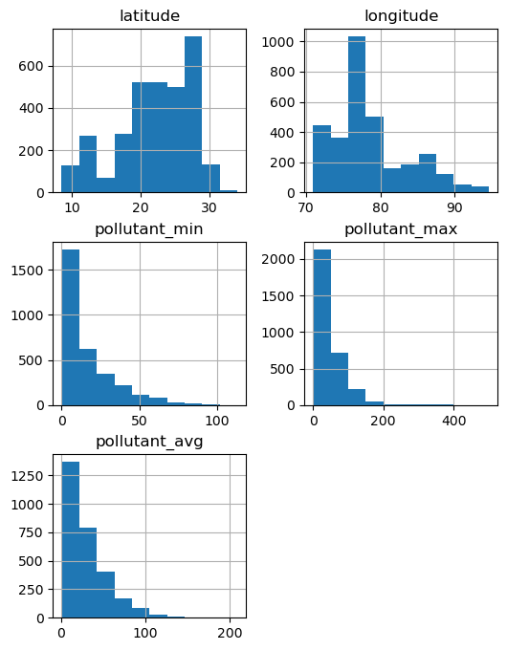

- I have decided to replace the null values with the mean of the pollutant of its respective city because the distributions are positively skewed and does not have any symmetry. Also, as the values are in a continuous scale and numerical values
- There were two cities that have all. Null values and the cities were Baghpat, Sri Vijaya Puram. So, I have deleted all rows having those cities.
- Even after all this there were some null values remaining. These null values were due to a single null value that was giving a null average. So, I have deleted those rows too as they had no significance.
- All this computation is done with Python.

SData Analysis
After data cleaning I have extracted the data as a csv and opened it in excel.

Cities with the most pollutants with respect to the pollutant average:

- CO (Carbon Monoxide):
Bar diagram representing the CO pollution of all states

Max Affected State: Jharkhand
2. NH3 (Ammonia):
Bar diagram representing the NH3 pollution of all states

Max Affected State: Himachal Pradesh
3. NO2 (Nitrogen Dioxide):

3. O3 (Ozone):
Max Affected State: Himachal Pradesh

4. PM10

Max affected State: Himachal Pradesh
5. PM2.5

6. SO2 (Sulphur dioxide):

Max Affected State: Nagaland

Which pollutant is present the most in which cities
State | City | Pollutant
Odisha | Keonjhar | CO
Maharashtra | Boisar | NH3
Bihar | Boisar | NO2
Kerala | Thiruvananthapuram | OZONE
Punjab | Mandi Gobindgarh | PM10
Karnataka | Madikeri | PM2.5
Karnataka | Haveri | SO2

These cities exhibit the highest recorded pollutant concentrations in the dataset and may require closer environmental monitoring.
Which pollutant is present the least in which cities?
state | city | pollutant
Bihar | Katihar | CO
West Bengal | Siliguri | NH3
Jharkhand | Dhanbad | NO2
Gujarat | Ankleshwar | OZONE
Maharashtra | Kalyan | PM10
Assam | Byrnihat | PM2.5
Karnataka | Haveri | SO2

These cities are the least harmful to live in and should be avoided
Distribution of the pollution_min, pollution_max and pollution_avg columns:

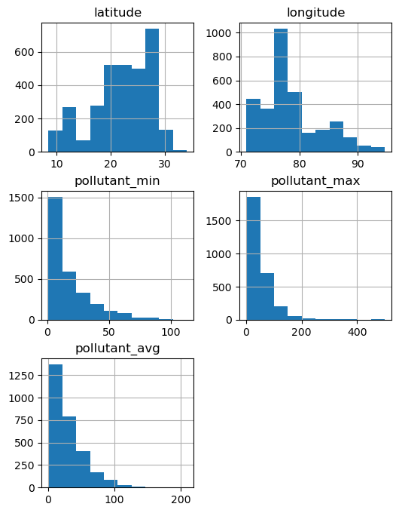
,

- Here we can see that the columns are very positively skewed
- Most cities have relatively moderate pollution
- A few cities have extreme pollution spikes
- There are many extreme values indicating that some cities may experience extreme pollution, but average pollution is less
- High pollution in cities pull the mean upward and Pollution is not uniformly distributed across cities
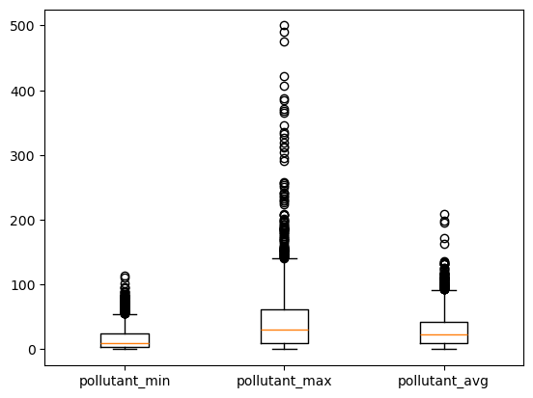

Boxplots of Pollutant Parameters
Interpretations:
- There are outliers and the column pollutant_max has the greatest number of outliers present in the dataset
- There are values extremely larger than the median values and some even exceed 500
- The Average pollution is much lower than pollution_max and it indicates that extreme pollution levels do not occur constantly and most cities experience pollution spikes occasionally, but they receive average values most of the time
- Minimum pollution has the smallest range and it has the lowest median value as expected.
- Variation of pollutant levels vary to a great extent among Indian cities and even though the max pollution produces very high values than the average pollution columns but most of the cities get a moderate amount of pollution level.

Correlation Between Pollutants:
In the dataset there is no raw data about the amount of pollutants present. So we took the pollution average column and we got every pollution average of every pollutant of each city to measure the correlation between the pollutants and the correlation matrix came out to be
 | PM2.5 | SO2 | CO | NH3 | OZONE | PM10 | NO2
PM2.5 | 1.000000 | 0.094047 | 0.152042 | 0.109996 | 0.097673 | 0.683755 | 0.046014
SO2 | 0.094047 | 1.000000 | 0.025040 | 0.023070 | -0.023750 | -0.086981 | 0.166825
CO | 0.152042 | 0.025040 | 1.000000 | 0.144524 | 0.127274 | 0.125626 | 0.141862
NH3 | 0.109996 | 0.023070 | 0.144524 | 1.000000 | 0.221750 | 0.285677 | 0.307909
OZONE | 0.097673 | -0.023750 | 0.127274 | 0.221750 | 1.000000 | 0.287432 | 0.255566
PM10 | 0.683755 | -0.086981 | 0.125626 | 0.285677 | 0.287432 | 1.000000 | 0.156655
NO2 | 0.046014 | 0.166825 | 0.141862 | 0.307909 | 0.255566 | 0.156655 | 1.000000

And the heatmap of the correlation between the pollutants came out to be
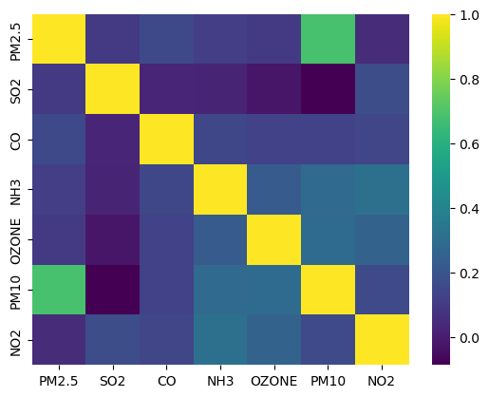

Here we can draw the interpretation that:
- There is a very high correlation between PM2.5 and PM10
- There is moderate correlation between NH3 and NO2, PM10 and NH3, PM10 and ozone, NO2 and Ozone
- SO2 has the weakest correlation with most Pollutants
- The strong correlation between PM2.5 and PM10 suggests that these pollutants often originate from similar sources such as vehicular emissions, construction dust and industrial combustion.

Region-wise Analysis
We divide the states into 4 regions – East, West, North, South
The states corresponding to the regions are
East: Bihar, Jharkhand, Odisha, West Bengal, Assam, Arunachal Pradesh, Nagaland, Tripura, Meghalaya, Sikkim
West: Gujarat, Maharashtra, Rajasthan, Madhya Pradesh, Chhattisgarh
North: Delhi, Haryana, Punjab, Himachal Pradesh, Jammu and Kashmir, Ladakh, Uttarakhand, Chandigarh
South: Andhra Pradesh, Karnataka, Kerala, Tamil Nadu, Telangana

So, we start the analysis with the pollution averages between the four regions:

- Here we can see that North has the highest levels of pollution. As it includes some very polluting states like Delhi, which is infamous for its pollution levels.
- The East and South region have the lowest pollution levels.
Now let’s compare the counts of the entries of the regions – the frequencies of the entries of the regions.

- Here we can see that west has the highest number of entries even though it has the highest number of entries
- Also East has the lowest number of entries. It may happen that some cities in the north have less pollution and it drops the average of the region.
- East and South have similar numbers of entries and their pollution levels are similar too.

Box Plots of all pollutants divided by Regions:

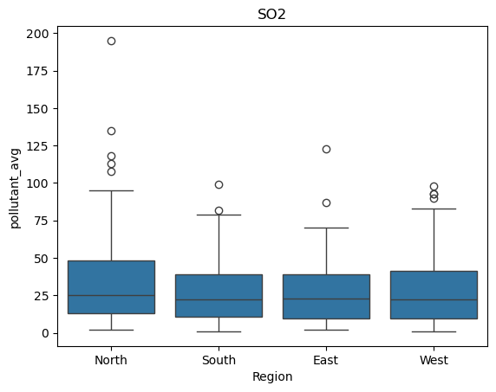
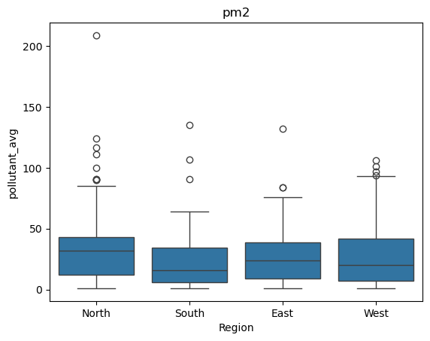

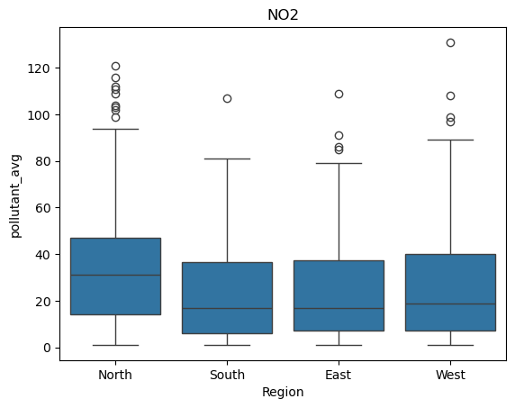
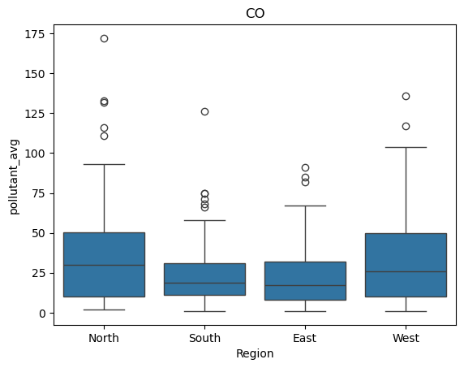

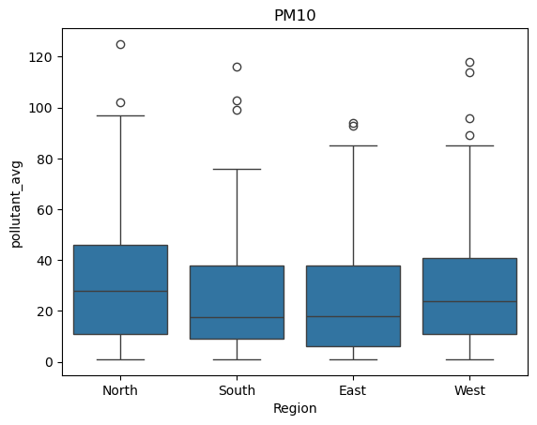
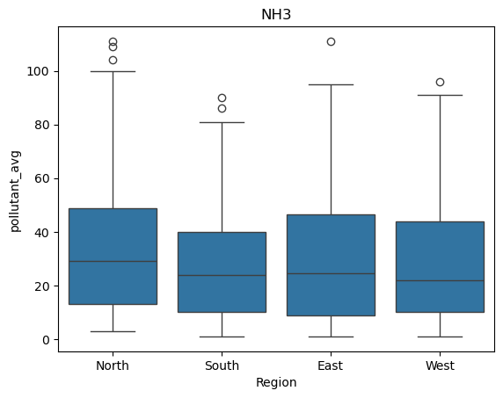

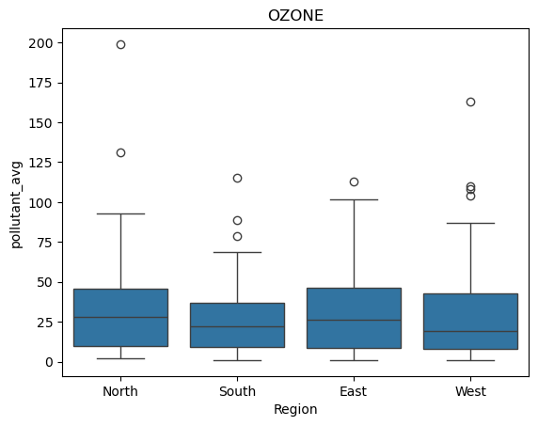

Interpretations:
- The boxplots indicate that the North region generally has higher median pollutant levels across several pollutant categories, particularly PM2.5, PM10, NO₂, and CO. This suggests that northern cities tend to experience higher pollution concentrations compared to other regions.

• In contrast, the South region consistently shows lower median pollutant levels across most pollutants. This indicates relatively better air quality and more stable pollution levels in southern cities.

• All regions exhibit outliers, indicating that extreme pollution events occur across the country. However, the North region contains the largest number of extreme values, especially for CO and particulate matter, suggesting occasional severe pollution spikes.

• The West region also shows several unusual outliers, indicating localized pollution hotspots despite moderate median levels.

• Overall, the South region demonstrates lower variability and fewer extreme pollution events, while the North region shows greater variability and higher pollution concentrations.

Ranking overall pollutant levels:

- North has the most pollutant levels, and it has been proven before with box plots and bar diagrams
- South has the least pollutant levels as per our analysis

Limitations of the Study
- The dataset contains aggregated statistics (minimum, maximum and average values) rather than raw hourly pollutant measurements.
- Missing values were replaced using mean imputation, which may slightly affect the true distribution of pollutant concentrations.
- Some regions contain more monitoring stations than others, which may influence regional averages.

